log 2tion ()araghraph textroung:log 2tion ()araghraph textroung:Line wraps error:



Text under the image: (remove it) (blog 1)



Heading and Paragraph text formation (Blog 2)



Separate the paragraph in brackets (blog 2)



Bullet points are in paragraph, should be in separate line and the part in brackets is another paragraph (blog 4)

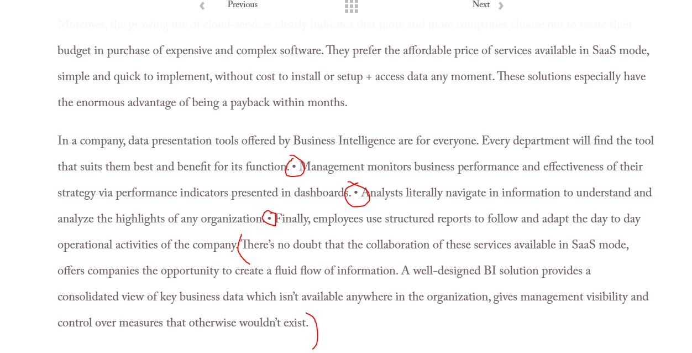

New Paragraph: (blog 3)

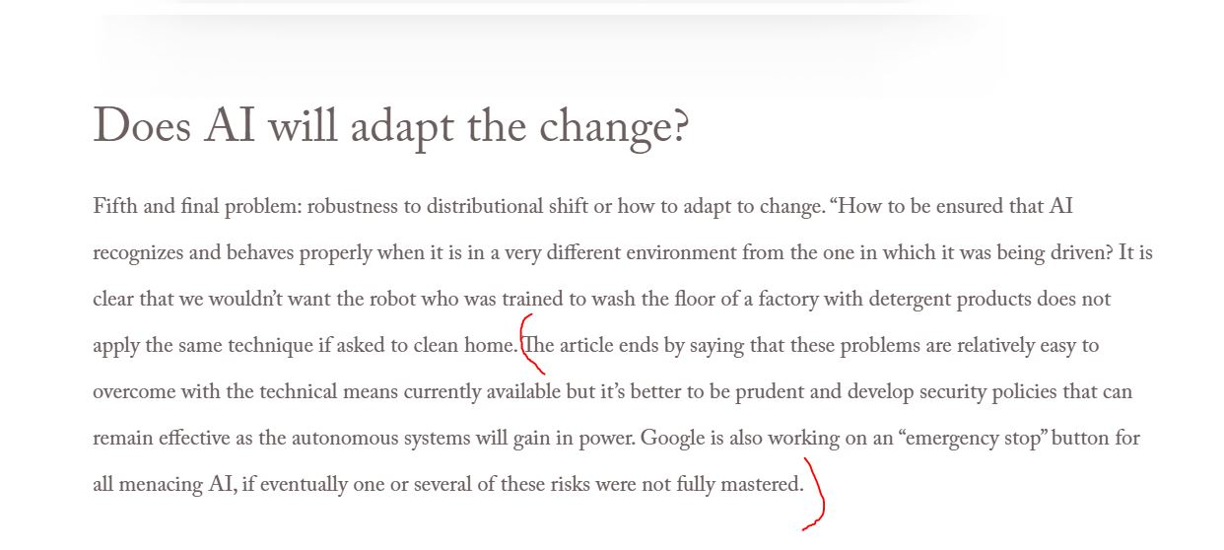

log 2tion ()araghraph textroung: